**Alpaca Dashboard**

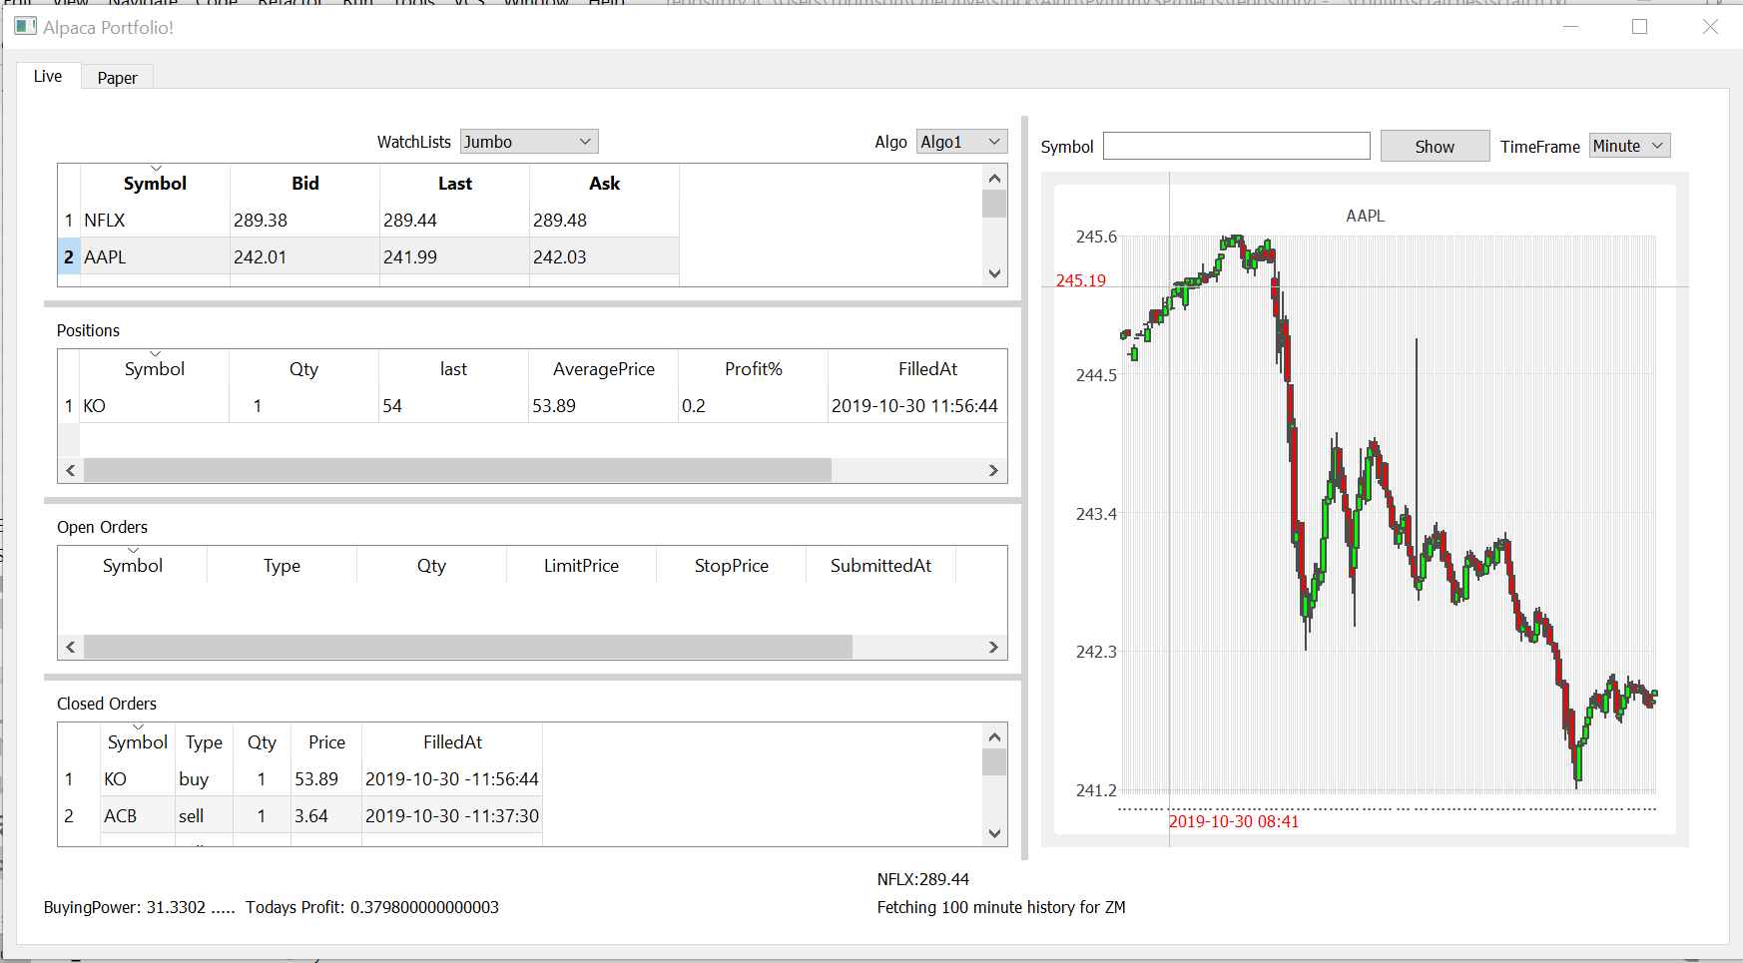

**This GUI dashboard has the following features:**

* Shows all positions in your portfolio (Live and paper environment)
  + Easily allows you to switch between environment
  + Right click on a stock will allow you to close the position
  + Last price and profit are realtime data
  + 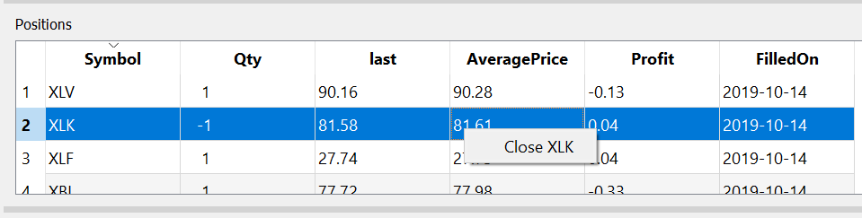
* Shows all open orders in your portfolio
  + Right click on the stock will allow you cancel the selected stock or all open orders
  + 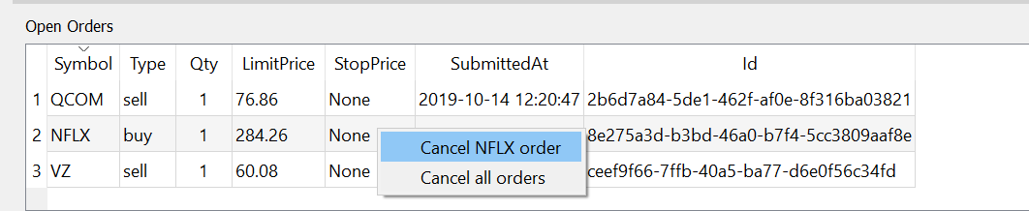
* Shows last 500 closed order
  + Click on any symbol to see realtime chart
  + 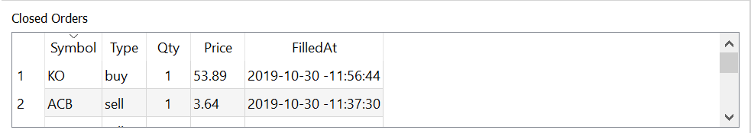
* Display real time candle stick chart for a selected stock
* Allows you to implement watchlists in your python code and display those in the dashboard
  + I have provided 4 watchlist, two of them are static watchlist and two are scanner watchlist which run at regular interval, you can add more with very few change to the code
  + Dashboard allows you to select the watchlist from a combo drop down
    - Bidprice and Askprice are realtime data from polygon streaming api
    - Right click on askprice allows you to buy the stock
    - Right click on bidprice allows you to sell the price
  + 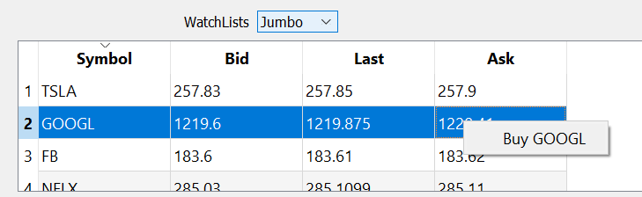
* Allows you to implement your own Algo routine to buy and sell in the python code and gives you the ability to select algo independently in each environment that run in the background
  + 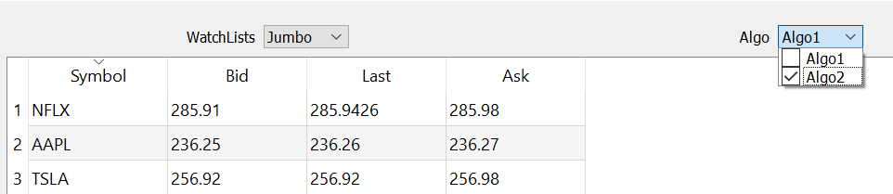
* Clicking on the watchlist, positions, open order, closed orders stocks displays a candle stick chart with realtime data
  + Chart show a crosshair with the price and time
  + You can select the chart timeframe from the drop down, currently minute and day timeframe are implemented, you can add more with very few change to the code
  + Allows to zoom into the chart
  + Right click on the chart allows you buy or sell the stock at limit or stop price depending on where you click
  + Right click also allows you to reset zoom
  + 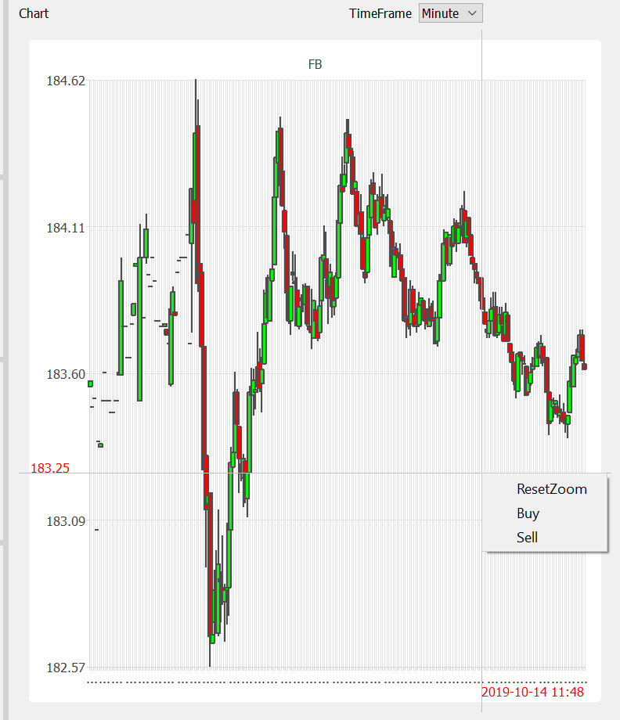
* Buy and sell request opens a dialog, with selected price and qty as applicable
  + 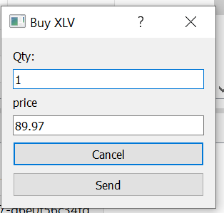
* The title shows the portfolio buying power
  + 
* Status area show all messages related to buy and sell, also show if the stock is traded by dashboard or from a algo, portfolio, watchlist and ticks



* **The Algo and Watchlist are samples, you can modify and implement your own**
* Reliability of realtime data depends on the Steaming API
  + All the symbols in the watchlist, positions and open order are subscribed
* GUI is using PySide2 library
  + You need to pip install PySide2
* The Python code uses Signal and Slots and I have kept the GUI and Data Logic totally independent, they talk to each other using the signal defined in the controller section of the code
* All of the code runs in its own thread

**There could be errors, but this is my first Jab at GUI in python, give it a try and modify and make it robust!.**